Enjoying music together at home

A list of ideas and apps for music making and interaction in the house or on the go.

## Be creative

* Sing familiar songs
* Play instruments along with a variety of music
* Explore instruments and sounds (toys, music apps)
* Sound effects to go with stories
* Choose stories with rhyming text

## Ways to listen and respond

* Choose music to enjoy alone or together
* Calm/ chill
* Draw, paint, make, play with fiddle toys
* Dance, rock, sway, march
* Make a playlist of favourites
* Body movement – actions e.g. move arms, nod head
* Body movement – blanket/ sheet with soft toy being bounced (keep beat)
* Body percussion – e.g. clap hands, stamp feet, tap shoulders
  + Input from adult – e.g. massage/ story massage; tap beat, make shapes, fast slow etc.

# Music related skills

* **Maths**
  + Choosing
  + Sorting
  + Colour
  + Shape
  + Turn into art and photograph
  + Awareness of beat and counting (music is often counted in 4 or 8)
  + Turn taking
* **Literacy and Language**
  + Rhymes
  + Word rhythms
  + Stories with music
  + Nursery Rhymes
* **Health and Wellbeing**
  + Self-expression (calm/ energetic)
  + Mood regulation (destress/ create interest)
  + Bringing people together (sing or make music with friends and family)

# Space for music

* Can be anywhere but best if it can be focused without distractions
* On the floor with a bag or box of things that make interesting sounds such as home made instruments
* Consider making a blanket den as a calm space to make music/ chill/ read stories
* Structure the sessions –
  + familiar/ action songs to engage and warm up
  + play and explore instruments
  + move to burn off energy
  + chill to get ready for the next thing in the day.

# Instruments

* Instruments don’t have to be keyboards, ukuleles or guitars. Consider making your own together and decorating them e.g. <https://www.youtube.com/watch?v=ZJk1h7uUAvo&feature=youtu.be>
* Sounds from the house e.g. Pots, pans and wooden spoons
* Explore sound with your phone:
  + Make a sound journey using a phone to make short video clips of sounds encountered in different spaces.
  + Cupboards opening and closing, car sounds, a walk around the garden with leaves, plants, wind etc. Pets
  + Video relatives, friends or neighbours saying “Hello” and play them back. Can you guess who it is? If you have access to an app like iMovie, put them together to make short movie.

Apps

(lists and reviews on websites)

* <https://www.commonsense.org/education/top-picks/great-apps-games-and-websites-for-music-education>
* <https://www.educationalappstore.com/best-apps/5-best-music-apps-for-kids-to-play-and-listen>
* <https://www.educatorstechnology.com/2014/02/30-ipad-apps-for-music-teachers.html>
* <https://midnightmusic.com.au/2019/06/35-free-ipad-apps-for-music-teachers/>
* <https://www.educatorstechnology.com/2014/02/30-ipad-apps-for-music-teachers.html>

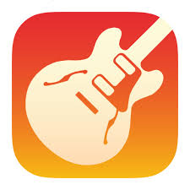**GarageBand (free, Mac and iOS only)** This highly sophisticated app shouldn’t put anyone off. From recording, effects, multitracking, jamming with others and virtual instruments, it may seem overwhelming to some, but it is also easy to get started and begin playing around. Virtual instruments include drums, bass, guitar, keyboards and orchestra. With lots of online tutorials on YouTube and elsewhere, it is possible to take it as far as you like.

**Ideas**:

* Open up, select an instrument and just play. Try different settings within the instrument environment. What is your favourite?
* What are the other instruments? Discover the instruments of the orchestra.
* Build beats using the drum machines
* Play relaxing music
* Play music to dance to
* Play along to a favourite piece of music
* Use the microphone to record your voice and pass it through the various effects such as Robot or Alien. Which is the funniest? Which friend or relative sounds funniest?

**Soundforest** (Free) Compose a song using a collection of creatures, trees, flowers and shapes. Each icon/image represents a different sound which you add to the project area to create a piece. The vertical position of an icon will affect the pitch (even with rhythmic sounds). Soundforest is very visual, using graphic-style notation to represent your piece and perfect for younger students. The free version has limited projects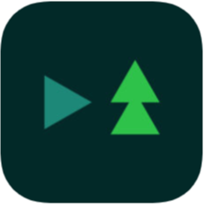

**Bandimal** (£3.99) For iOS-infused preschool and kindergarten classrooms, this could be an excellent intro to electronic music. Build up layers of music over 8 beats, vary pitch. Characters move engagingly to the music which gives it an edge over SoundForest. Doesn’t have as many sounds or layer options as SoundForest, but that may be helpful for some.

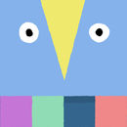[**Loopimal**](https://www.educationalappstore.com/app/loopimal)(£3.99 iPhone, iPad ) Similar to Bandimal and by the same people, Loopimal is a seriously fun music app that allows kids (and adults alike) to explore sequences, loops, and music as they try to animate a bunch of cute animals. Children have endless opportunities to create rich compositions and explore loops and computer sequencing within an easy-to-use pre-programming framework.

Kids can learn about components of music such as beat, rhythm, melody, tempo. As they create patterns of up to eight musical blocks that repeat endlessly, kids experience visual and auditory loops and sequences. The animals' movements also help give a good sense of tempo and movement as it relates to music.

* Encourages reading left to right
* Anticipation of beats, visual actions and pitch
* Recognition of patterns
* Recognition of shapes

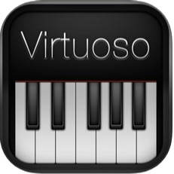Virtuoso Piano 3 (free). Play chords or single notes on an on-screen piano. Variety of playback sounds (including guitars. Shows note names on the keys. Change range of notes. Split screen. Could be useful on a phone.

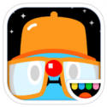Toca Band (£3.99) Pros: Catchy groove loops draw in kids with all their senses; highly interactive interface has great responsiveness. Cons: The app is limited to one song and has no in-app record/save function. Bottom Line: Toca Band gives kids an engaging, hands-on music creation experience, but lacks the ability to save their masterpieces. <https://www.commonsense.org/education/app/toca-band>

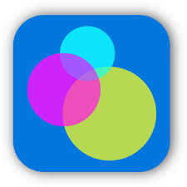Bloom (£3.99) Create or listen to calming music with colourful visuals. Very intuitive and doesn’t require strong motor skills.